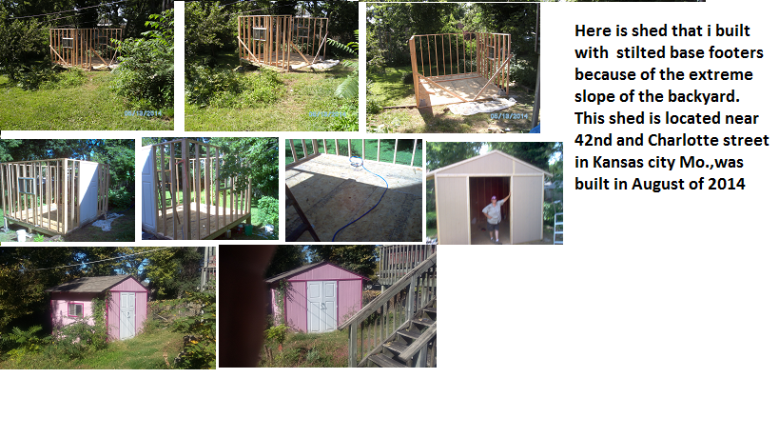
08/13/2014
Here is shed that i built with stilted base footers because of the extreme slope of the backyard. This shed is located near 42nd and Charlotte street in Kansas city Mo.,was built in August of 2014

